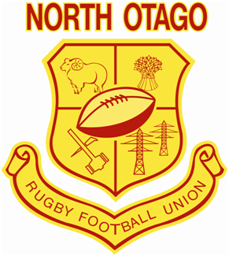

North Otago Rugby

Football Union

Code of Ethics

06 March 2025

**INTRODUCTION**

The North Otago Rugby Football Union has a proud history of fostering rugby talent and a commitment to grassroots rugby throughout all of North Otago. The NORFU has a strategic commitment in improving communities through rugby focused initiatives, and that communities rally around local rugby clubs to support their local players in sport.

Rugby must be played within the spirit in which it was intended. It is to be played both to the letter and within the spirit of the laws. The responsibility for guaranteeing this lies not with one individual - it involves coaches, captain, player’s referees and spectators.

The NORFU Code of Ethics is created to provide the framework for clubs to ensure every person that decides to interact with the North Otago Rugby Union has an enjoyable experience while doing so. This will ensure that the North Otago Rugby Union continues to create superior communities, through superior rugby experiences.

**HOST RESPONSIBILITY FOR CLUBS**

**FIXTURE DEFINITION**

Host responsibility begins 1 hour before the first fixture at the venue/venues and concludes at the closing of the clubrooms.

**AFTER MATCH SPEECH**

After match speeches should be conducted in a personable and respectable manner. There will be no derogatory or malicious comments by any parties.

**Match Day Manager**

Each club shall be responsible for appointing a Match Day Manager (MDM/s) for all rugby matches. MDM’s could normally be the Club Captain or a committee person that holds respect within the club environment. The MDMs must wear the appropriate fluorescent jacket indicating that they are the Match Day Manager.

The MDM’s will ensure

* Visiting teams and match officials are met
* Teams and referee changing rooms are open
* Provision of locks and keys for changing rooms
* All grounds have barriers/safety ropes/safety padding in place
* Policing of all people to ensure they remain behind the safety ropes, other than those referred to in match day protocol-Sanctioned personnel only allowed inside the ropes.
* Ensure all coaches, assistant coaches, managers, water carriers/tee carriers and players stay in the team allocated area (Technical Zone) while game is in progress. (refer to attached field at the back of this book)
* Any side line abuse of referees or unruly behaviour is immediately addressed and offender appropriately dealt with in accordance to the processes as outline under Referee Abuse and spectator behaviour.
* No alcohol is to be consumed within the playing enclosure (within 5 metres of the field outer marking)

**FIELD PREPARATION**

Clubs will ensure that fields are adequately roped to ensure the safety of players, spectators and match officials. Ropes are to be at minimum 3 metres from each touchline where possible, and run the length of the playing area, from dead ball line to dead ball line (refer to field setup options appendix 4)

MDM’s are to ensure that any stretching/pushing of the ropes does not lead to spectators encroaching into this area. If this cannot be managed, the ropes are to be positioned further away from the touchline.

Ensure post pads are fitted and field flags are in position.

**MATCH DAY PROTOCOL**

Authorised persons that are permitted inside the ropes:

* Referee
* Assistant Referees
* Ball Boys
* Physio/Medic/Water Carriers:

A maximum of four (4) personnel are permitted to fulfil the roles of medics/water carriers. Medics and water carriers must wear the relevant bib/identification and composition may be any of the following:

• One Medic and up to three water carriers- the medic or a water carrier (but not both) may operate from the far side of the field.

• No medics- a team may have up to four water carriers. One water carrier may operate from the far side of the field.

• Note: an Assistant Coach is permitted to be a water carrier

Water carriers

• Water may only be taken on the field during stoppages in play. These are when:

o There is an injury in the playing area and

o A try has been scored.

• The water carriers are not permitted in the playing area during penalty kicks at goal.

• Water bottles must not be thrown on to the field of play

• Water carriers must not obstruct, interfere or direct comments at Match Officials.

Medical personnel

• One of the medically trained people permitted as listed above may be positioned on the far side of the playing area on the touch line opposite the team benches and may move along the touch line.

Medics must not obstruct, interfere or direct comments at Match Officials.

Only designated personnel are allowed in coaching area, reserves area, and on field.Team management and players are to be positioned as per Club rugby field set up.

**Note:** It is the responsibility of team coaches and managers to ensure their team strictly complies with these requirements. Non Authorised person may only enter the playing area:

* To attend to an injured player during stoppages-St John and team officials only: can assist from the Technical Zone.
* To assist in removing an injured player from the field-St John, team officials, plus any nominated assistant.

The game is not to commence until:

* Barriers/rope/safety pads are in place.
* MDM is present.

The Referee is required to stop the game if:

* Unauthorised persons remain inside the ropes
* Any referee abuse or general disorderly behaviour of spectators that is not being addressed by the MDM.
* Any abusive/disruptive spectator or team member who does not abide with requests made of them by the MDM
* Any player ordered from the field who does not immediately leave the playing enclosure **NON COMPLETION OF FIXTURE**

If the referee has to either ***Stop*** or ***call off*** a game, the referee and MDM are to complete a Match Incident Report and forward to NORFU Office within 48 hours of the match ending.

**REFEREE ABUSE AND SPECTATOR BEHAVIOUR**

Any incident of referee abuse, disorderly behaviour or alcohol consumption by spectators or team members within the playing enclosure, is to be addressed in the first instance by the appointed MDM. If required, the MDM is to seek the assistance gain support of other club officials and/or the match referee to ensure the enforcement of sanction provide to offending parties are complied with. If any of the above incidents occur during a match, including Referee Abuse or general disorderly behaviour of spectators, the MDM should adopt the following process:

* Approach the offending parties to identify them. Request the offending parties to cease from behaviour concerned. Indicate to them that if they do not comply they **WILL** be asked to leave the playing enclosure.
* If they fail to comply, call for assistance of other club officials and the match referee. Referee to support sanction. Offender is asked to leave the complex
* If non-compliance continues, the referee is to call the match off.

**ABUSE DEFINITIONS**

Abuse is defined as to attach with coarse or insulting, rude, threatening or maligning language or behaviour.

**Verbal Abuse is as follows**

* Any form of foul language
* Any form of racial or discriminatory behaviour
* Any form of threatening language
* Continual complaining/sledging
* Personal insults
* Dissent by players
* Any insults or personal attacks published in all forms of media including social media in or on a club affiliated domain

Physical abuse is as follows:

* Pushing
* Bumping
* Spitting
* Kicking
* Punching
* Any form of attempt of the above
* Any form of threatening behaviour

**Note:**

***At no times shall the MDM, assistants or the match referee confront any offending parties physically.***

**REPORTING OF REFEREE ABUSE OR SPECTATOR BEHAVIOUR**

On all occasion that for any of the reasons outlined:

* A spectator is ejected from the ground
* The match has to be stopped
* The match has to be called off

Both the MDM and the match referee (if called upon to assist) shall forward a Referee Abuse Form to North Otago Rugby Football Union within 48hrs of the match ending, detailing a summary of the incidents(s) plus information leading to the identification of the offending party concerned.

**COMPLAINTs**

Any match-day complaint/ citing’s regarding foul play or on field/off-field behaviour **that has gone undetected by the match officials** must be made in writing to the NORFU Office who will in turn inform the Complaints Review Officer, who will establish if the complaint is to proceeded with. If the Complaints Review Officer determines that there are grounds for the complaint, the matter will be passed to the Chairman of the Disciplinary Committee for hearing.

**Referee Protocol**

Referees are to adhere to the match day protocol and report any breaches to the NORFU. The referee is not permitted to waive the procedures contained in this policy. If they do so the accept responsibility as the match official for the consequences that occur and realise they could have taken measures to rectify the situation.

**INITIAL COMPLAINTS PROCEDURE**

Judicial Committee have the jurisdiction to hear and determine a

Complaint of illegal and/or foul play against Player (“a Complaint”) in respect of any act of illegal and/or Foul Play which has not been detected by the Match Officials in a Match for which the Union has jurisdiction.

1. A complaint under Rule 19 may be made by:
2. The CEO of the NZRU or his nominee;
3. The CEO of the Union or his nominee or Citing Commissioner (where appointed by the Union);
4. The Secretary of a Club involved in the match;
5. The North Otago Rugby Referees Association; and
6. All other persons
7. A complaint under rule 19 shall contain the following information:
8. The date and place of the alleged illegal and/or Foul Play;
9. The name of the player in respect of whom the Complaint is made (and his jersey number) and the team he was playing for at the time of the alleged illegal and/or Foul Play;
10. The name of the opposition team; and
11. Full detail of the alleged illegal and/or Foul Play
12. On receipt of a Complaint brought (other than a Complaint brought with leave under rule 21 92), the CEO of the Union shall immediately refer the Complaint to the Union Complaints Review Officer.
13. On receipt of a Complaint brought with leave under Rule 21 (2), the Chief Executive Officer of the Union shall proceed as required by Rule 6 24(4) as if notification has been received from the Union Complaints Review Officer that the Complaint should proceed to a hearing before the Judicial Officer or Judicial Committee.

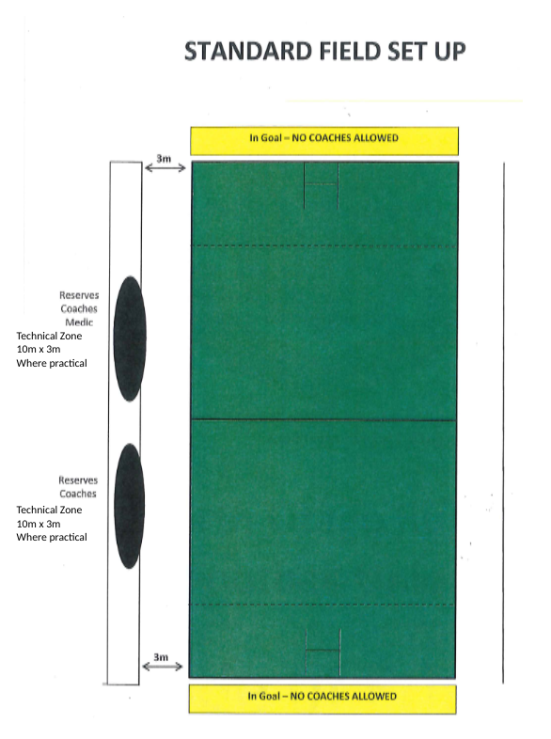



**North Otago Rugby Football Union**

**Code of Ethics Declaration**

The ……………………………………………………………………Club/School agrees to enforce the North Otago Rugby Football Union Code of Ethics.

**Signed:………………………………………………………………………**

On behalf of **ALL OUR CLUB OR SCHOOL TEAMS** entered into the 2025 North Otago Club Rugby Competitions.

Club/School:**……………………………………………………………….**

By (name): **………………………………………………………………….**

(Position): **………………………………………………………………….**

Dated this ………………………….day of …………………………. 2025.